**Developed and Prepared By:** Ajunumasa Sadanandan

**Development Man-days:** 5

**Document Submission Date:** 04-10-2020

**Git Hub Link :**

**Project Details**

**Project Name**: File Management System

**Project Description:** Create a File Management System Menu driven software, which should perform actions like create, delete, search and sort files based on the user selection.

**Language:** Java 8

**Methodology:** Agile Scrum Methodology

**Sprint required**: 2

**Story Points** = 10

**Software’s Used:** Eclipse - Project Development

**Java Concepts Used:** Classes, Interfaces, java nio, Exception Handling, Scanner, Collection framework

**Project Description in Detail**

Based on the requirement from **Company Lockers Pvt. Ltd**, I developed a menu driven application for File Management, which have 5 option and it works based on the user entered input.

And it has the option to Navigate back to the main context as well.

* **Menu 1** – SORT and DISPLAY the Files of the root directory in Ascending Order
* **Menu 2** – ADD the file to the directory, if filename doesn’t exist in the directory then ADD else Reject
* **Menu 3-** DELETE the file from the directory, if the file exists then DELETE else return File not found.
* **Menu 4** – SEARCH for the given filename, if exist then return the path else return file not found.
* **Menu 5** – EXIT the application

**CONSOLE with Menu options:**

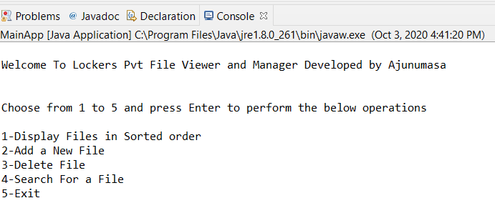

**Menu 1 - SORT and DISPLAY the Files in the Ascending Order:**

* Used **Collections** framework from Java.
* Used **Stream** to list the files and sort method in Stream for sorting in ascending order.
* Filter option in Stream is used to check the condition regarding the File.
* if the user enters the input as 1 then application will check files and gets the file names for the root folder and added to the Object and print those files using for each loop.

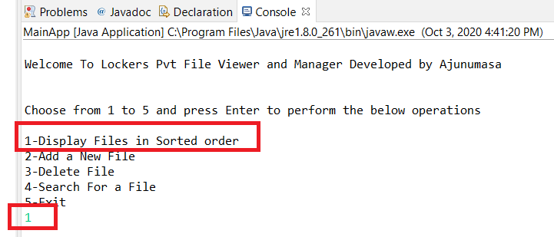

**OUTPUT**: For option “1” , Sort and Display in Ascending Order

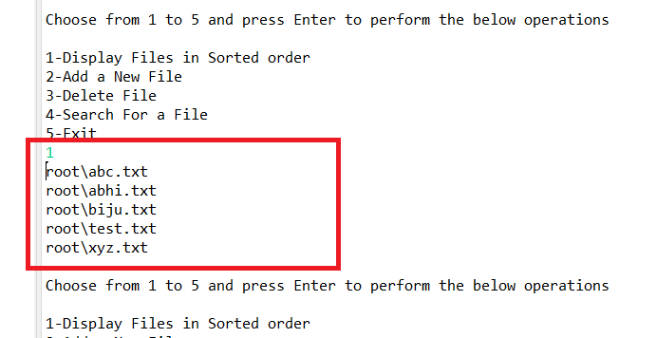

**Menu 2 - User can add new file if filename doesn’t exist in the directory**

If the user selects the menu 2 option means then the application allows the user to create a new txt file.

**ADD Files on root Folder**

* When we choose Option 2, it will ask for the filename to ADD and gets the user input file name from console and search if the file name already exists or not in the Root directory. If exists means then application will throw the exception and user gets the error message as "File Already Exists in the Directory" . On Successful file name creation, System displays the success message as "File created successfully"

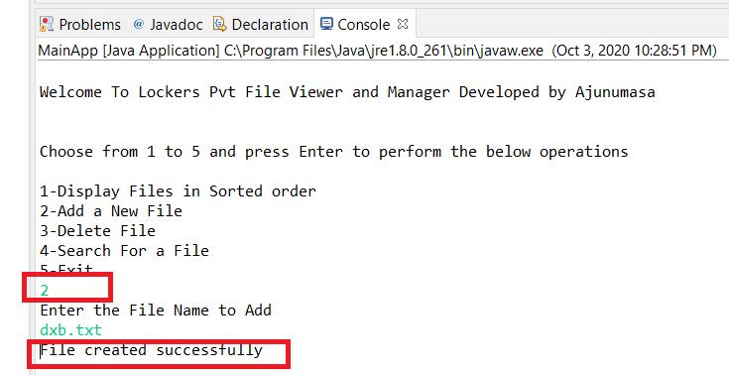

In case if file already exist in the Root directory then it will give the output as below:

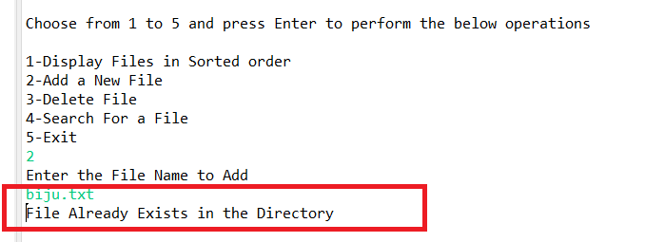

**Menu 3 - DELETE the file if exist in the root directory**

delete the txt file from the root folder

**Delete Files from root Folder**

* If we choose Option 3, it will ask for the filename to Delete and get the user input filename from the console and compares it with the existing file name in root directory. If it matches then it will perform the delete operation on the user input file name.
* If application removed the user entered file name then it displays the success message as "Deleted Successfully".

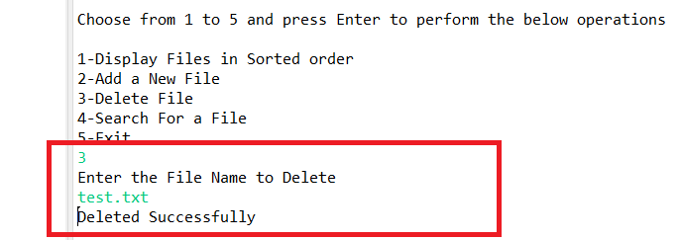

* In case of user-entered file name not present in the root directory means the application will return the error message "File Doesn't Exist".

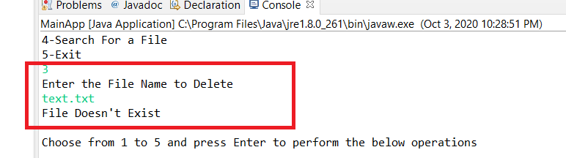

**Menu 4 – SEARCH the filename**

It search the txt files based on the search pattern

**Searching Files from root Folder**

* The application performs a search operation for the given filename in Root directory. EXISTS() method searches for a file in the directory irrespective of case -sensitivity

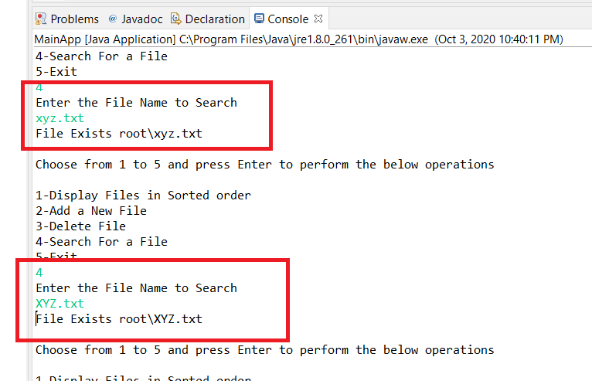

* It will return error message as "File Not Found" if the file not exist in the directory

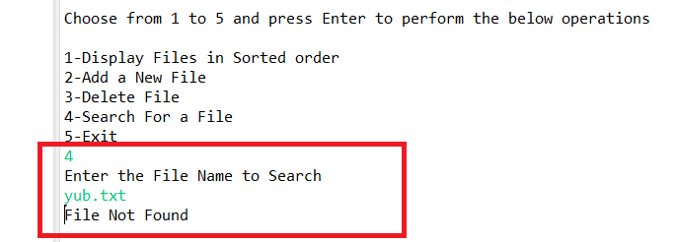

**Menu 5 – EXIT the application**

Application having the option to exit at any case based on the user input. If the user selects to perform this option means the application ends its process and return the message "Thank you for using Lockers Pvt.com SEE YOU SOON!!"

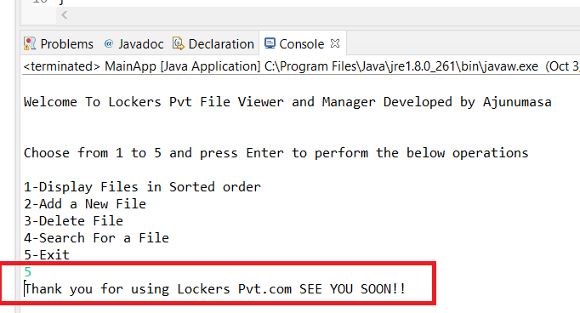

In case if the user entered the wrong input means then the application throws the error message as "Choose the Correct option from 1 to 5 to perform the below operations"

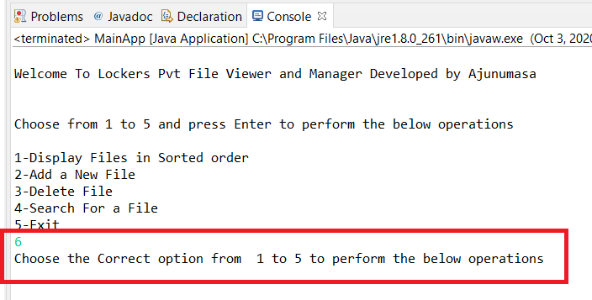

*** END OF PROJECT DESCRIPTION IN DETAIL***

**FLOWCHART:**

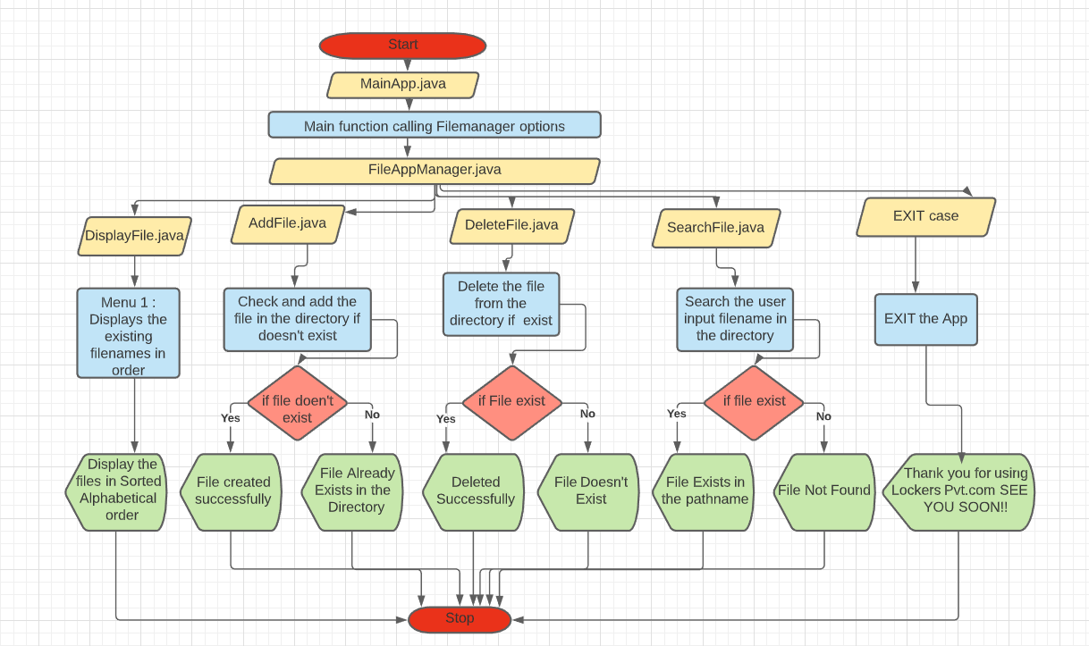

**USER STORY POINTS**

|  |
| --- |
| Create Console App For Locked Me Operations – 1 |
| Analyse Requirements Of LockedMeApp -2 |
| Create Add Method For File Creation -1 |
| Create Delete Method For Locked Me App-1 |
| Unit Test of Create And Delete Methods And Defect Fixes-1 |
| Create Method for Search Operation-1 |
| Create Method For Display Operation-1 |
| Unit Testing of Search and Display Operation-1 |
| Environment Setup, Daily Stand Up, Retrospective Meetings, Sprint Demo-1 |
|  |